

Use-Case Model

Version 2.4

Revision History
Date | Version | Description | Author
9/18/04 | 1.0 | High-level use cases | Nikolay Kojuharov
10/7/04 | 1.1 | Elaborated use cases | Nikolay Kojuharov
10/21/04 | 2.0 | Use-Case Model draft | Nikolay Kojuharov
11/18/04 | 2.1 | Integrated suggestions from Kinis | Nikolay Kojuharov
11/20/04 | 2.2 | Implemented Abort Indexing. Removed Clear Search Index. Added Swap Search Index. Integrated suggestions from David | Nikolay Kojuhaov
12/2/04 | 2.3 | Minor modifications and updated diagram | Nikolay Kojuharov
12/5/04 | 2.4 | Applied comments from the review | Nikolay Kojuharov

Table of Contents
1. Search+ 6
2. Search 7
3. Perform Search- 8
4. Change Settings 9
5. Build Search Index- 10
6. Swap Search Index- 11
7. Abort Indexing- 12
8. View Source Code 13
9. Add Support for New Language 14

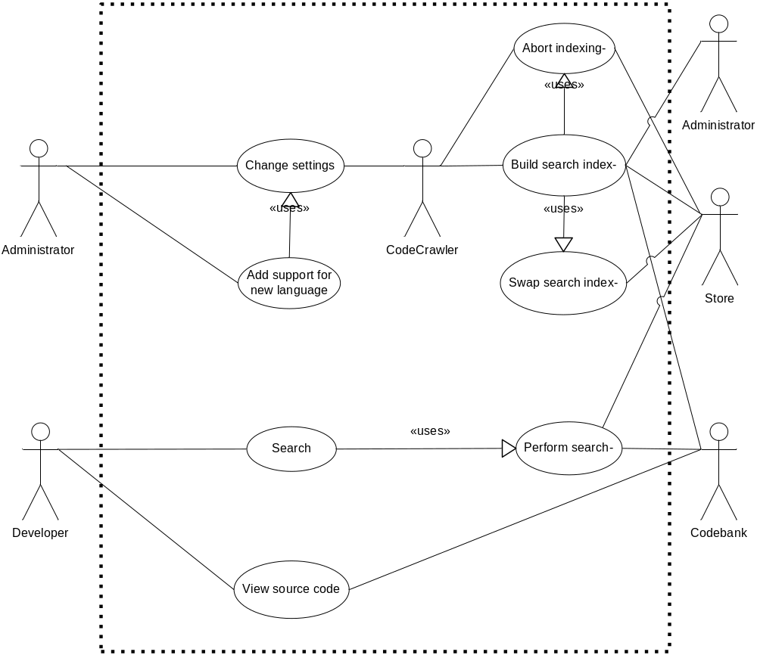

Figure 1. The CodeCrawler system’s use cases

Actor | Goal | Priority
Company | Search+ | 1
Developer | Search | 1
System | Perform search- | 1
Administrator | Change settings | 2
System | Build search index- | 1
System | Swap search index- | 2
System | Abort indexing- | 2
Developer | View source code | 1
Administrator | Add support for new language | 3

Search+
Primary Actor: Company
Scope: Business
Level: Summary
Stakeholders and Interests:
- Company: wants to increase developer productivity
- Company: wants a standardized product to facilitate a smaller learning curve for the developers
- Developer: wants to quickly find and view source code of interest
- Administrator: wants an easily configurable and maintainable system
Main Success Scenario:
- Administrator installs and changes system settings
- Administrator adds support for new languages
- System builds search index
- Developer searches and receives ranked results
- Developer views source code for returned results
Related Information: See project page

Search
Primary Actor: Developer
Context of Use: Developer wants to search the code
Scope: System
Level: User goal
Stakeholders and Interests:
- Developer: wants an easy interface to search the code
- Developer: wants powerful search options to precisely tailor a search
- Developer: wants quick responses
- Developer: wants accurate search results
- Administrator: wants to keep the system load low
Precondition: None
Minimal Guarantees: Developer will receive some notification about the outcome of the search
Trigger: Developer comes to the CodeCrawler search page
Success Guarantees:
- The search will present all results that match the query
- The search will not present any results that do not match the query
- The results will be sorted
- The results will give a preview of the actual source code
Main Success Scenario:
- Developer comes to the CodeCrawler search page
- Developer types in the search criteria
- Developer selects the default search configuration
- Developer submits the search query
- System performs search
- System displays search results according to default search configuration
Extensions:
*a. Network error – nothing can be done to remedy the situation
1a. Developer mistypes the search page URL
1a1. System cannot do anything to remedy this situation. To alleviate the problem, the System should provide an easy-to-remember URL
5a. Perform search fails
5a1. System displays the error encountered
Technology and Data Variations: Search could be initiated in several ways. See Requirements and UI for search options:
- from the basic search page
- from the advanced search page
- from the results page (sort by a new criterion, go to a different page of results, restart a new search)
Related Information: See screen prototype (also advanced search)
Mohan and Edward are responsible for this use case

Perform Search-
Primary Actor: Developer
Context of Use: Developer wants to search source code to find the best match to some search criteria
Scope: System search
Level: Sub-goal
Stakeholders and Interests:
- System: wants to complete search as quickly as possible without putting a strain on the server and network
- System: wants to allow other searches to proceed in parallel to this one
Precondition: None
Minimal Guarantees: Administrator will receive notification about any errors that might occur
Success Guarantees: Results page will be returned to the requesting client computer
Trigger: Developer initiates a search query
Main Success Scenario:
- System receives query
- System parses and validates query
- System searches the stable index in Store
- System filters out results that don’t match the search query
- System ranks results
- System fetches the files for the found matches from the Codebank specified in the settings
- System extracts code snippets from the fetched source files
- System converts the code snippets to web displayable form, using syntax highlighting and marking query matches
- System builds results page
Extensions:
1a. Network problems prevent the query from reaching the searcher – no action; out of the scope of this system
2a. Query is empty or invalid
2a1. Return an error page with the appropriate error as specified in the errors table
3a. Index cannot be read
3a1. Return an error page with the appropriate error as specified in the errors table
4a. No documents match the query
4a1. Return no results found page
6a. Fetching a file fails
6a1. Log error and do not display snippet
6b. File has been modified since the index was built
6b1. Log warning
8a. Formatting the code snippet fails
8a1. Log error and display the snippet as unformatted text
8b. File is binary
8b1. Do not display snippet
Related Information: See communication diagram (link TBD). See screen prototype
Martin and Nikolay are responsible for this use case

Change Settings
Primary Actor: Administrator
Context of Use: Administrator wants to change some setting of the System
Scope: System
Level: User goal
Stakeholders and Interests: Administrator: wants to change some aspect of the System
Precondition: None
Minimal Guarantees: System notifies Administrator whether the change was successful
Success Guarantees: System will behave under the newly specified settings
Trigger: Administrator logs in
Main Success Scenario:
- Administrator logs in
- Administrator starts the configuration utility
- Administrator changes the settings
- Administrator notifies the system of the changes
- System updates its configuration
Extensions:
1a. Authentication fails (incorrect username or password)
1a1. Display error and allow another attempt (TBD how many times)
3a. Choices made by the Administrator are invalid
3a1. Inform administrator of invalid choices and allow another attempt
4a. System does not respond to the change confirmation request – nothing could be done to remedy this situation
4a1. Administrator restarts the System
Technology and Data Variations: The configuration utility could be web based or a rich client
Related Information: See configuration utility prototype
Kinis and David are responsible for this use case

Build Search Index-
Primary Actor: System
Context of Use: Administrator schedules indexing to begin under certain conditions and the System decides that these conditions have been satisfied
Scope: System indexing
Level: Sub-goal
Stakeholders and Interests:
- System: wants to maintain the system integrity
- Developer: wants search results to be kept current
Precondition: Administrator has scheduled when the indexing should begin
Minimal Guarantees:
- Index will not be left in an inconsistent state
- Searching will not be disabled during indexing
Success Guarantees: Index has been created to reflect the latest versions of source code and the search will thereafter use the new index
Trigger: The schedule conditions have been satisfied
Main Success Scenario:
- System fetches files from the Codebank specified by the settings
- System detects the programming language of the source code and collects context information
- System associates context and file information with the files and adds them to the index
- System optimizes the index and stores it into Store
- System swaps the search index
- System notifies Administrator by e-mail that indexing has finished and attaches error log and index statistics
Extensions:
*a Indexing encounters a critical error
*a1. System logs the correct error and aborts the indexing operation
1a. Fetching a file fails
1a1. System logs an error and continues
2a. File extension does not match any CodeCrawler supported programming language
2a1. System logs a warning, and either skips the file or treats it as plain text as specified in the settings
2b. File extension matches more than one programming language
2b1. System assumes one of the possible languages, and logs a warning
2c. Context extraction fails
2c1. System logs an error and treats the file as plain text
3a. File cannot be added to the index
3a1. System stops the indexing process and logs an error
4a. Index optimization fails
4a1 System logs an error and leaves the index unoptimized
5a. There are existing searches under way that use the current index
5a1. All existing searches will finish before the current index is swapped with the new one
6a. E-mail notification fails
6a1 System logs an error and saves error log locally
Technology and Data Variations: The index might be stored in a database (TBD architecture)
Related Information: This use case has a sequence diagram (check out the web page).
Martin and Nikolay are responsible for this use case.

Swap Search Index-
Primary Actor: System
Context of Use: System finishes indexing and wants to replace the current stable index with the newly build index
Scope: System indexing
Level: Sub-goal
Stakeholders and Interests:
- System: wants to maintain system integrity
- System: wants to allow searches currently under way to complete
Precondition: The system is currently building an index
Minimal Guarantees: There will be a stable index
Success Guarantees: The new stable index will be the one just build. All existing searches will complete with the original index and all new searches will use the newly built one.
Trigger: Indexing completes successfully
Main Success Scenario:
- System updates the stable index location setting to point to the new index in Store
- System waits until there are no searches under way that use the deprecated index
- System deletes the deprecated index from Store
Extensions:
1a. Changing the index location setting fails
1a1. System aborts indexing
3a. Deleting the deprecated index fails
3a1. System logs an error, the Administrator should delete the deprecated index manually later
Related Information: Nikolay is responsible for this use case

Abort Indexing-
Primary Actor: System, Administrator
Context of Use: System encountered a critical error while indexing and has to abort or Administrator requests to abort indexing
Scope: System indexing
Level: Sub-goal
Stakeholders and Interests:
- Administrator: wants to keep the stable build
- Administrator: wants to delete the partial index
- System: wants to maintain system integrity
Precondition: The system is currently building an index
Minimal Guarantees: System will stop the indexing process
Success Guarantees: System will stop the indexing process and the partial index will be deleted
Trigger: System encounters a critical error or the Administrator requests to abort indexing
Main Success Scenario:
- System stops the indexing process
- System deletes the partial index from Store
Extensions:
2a. Deleting the partial index fails
2a1. System logs an error, the Administrator should delete the partial index manually later
Related Information: Nikolay is responsible for this use case

View Source Code
Primary Actor: Developer
Context of Use: Developer wants to view the summarized search results and drill down to file contents
Scope: System
Level: User-goal
Stakeholders and Interests:
- Developer: wants to view the full source code in the web browser
- Developer: wants to see the source code syntax highlighted with line numbers
- Developer: wants easy navigation between summary and detail pages
Precondition: Developer has performed a search and the results are displayed
Minimal Guarantees: System will either succeed or fail with a reasonable error message
Success Guarantees: System will display syntax highlighted source code for the requested file
Trigger: Developer clicks on a search result link
Main Success Scenario:
- Developer clicks on a search result link
- System fetches the requested file from the Codebank
- System converts the code to web displayable form, using syntax highlighting, marking query matches, and displaying line numbers
- System displays the file to the Developer scrolling down to the line of the first match
Extensions:
1a. Network problems prevent the request from reaching the System – nothing can be done to remedy the situation
2a. Fetching a file fails
2a1. Log error and display error to Developer
8a. Formatting the file fails
8a1. Log error and display unformatted file
8b. File is binary
8b1. Display error to Developer
Technology and Data Variations: Users should be able to view / download the original source code file
Related Information: See communication diagram (TBD link). See screen prototype
Mohan and Edward are responsible for this use case

Add Support for New Language
Primary Actor: Administrator
Context of Use: The Administrator needs to add support for new programming language to the System
Scope: System
Level: User goal
Stakeholders and Interests:
- Administrator: wants a flexible way to add support for new programming languages
- Administrator: wants to disrupt the System as little as possible
- Developer: wants to search source code in a new programming language using semantic categories
- Developer: wants to see source code in a new programming language syntax highlighted
Precondition: None
Success Guarantees: The System will have knowledge about the new programming language
Trigger: Administrator has been instructed to add support for a new programming language
Main Success Scenario:
- Administrator creates a language definition for the formatter
- Administrator creates a language highlighting style for the formatter
- Administrator creates a language definition for the code analyzer
- Administrator changes language settings
Extensions:
*a. Disk error – nothing could be done to remedy this situation
4a. Changing the settings fails
4a1. Administrator verifies language files and tries changing the settings again
Technology and Data Variations: This use case depends a lot on third party components. Highlight supports defining new languages, so does CTAGS (although in a more limited way). For code formatting other possible third party components are WebCpp and Code2Html
Related Information: Sequence diagram (TBD link)
Jebeh and Adam are responsible for this use case

